***Circus of Plates***

***Aly Tarek Ibrahim # 39***

***Mohamed Ahmed Abo el-Hassan # 55***

**Description of usage of design pattern in the game :**

***MVC :***

The ***project*** can be divided into ***three*** parts . ***the model*** , ***the view*** and ***the controller*** .   
the model is represented through all the classes of the project except for two classes .

One of them is named view and it contains all the members related to the view of the game , the ***GUI*** and buttons and so on .

The other class is the controller class which is responsible for controlling changes that takes place through model regarding the ***data*** or the ***behavior*** and impacting this change on the view class .

So this design pattern is responsible for the separation of these ***three components*** .

***Singleton :***

Singleton is used ***many times*** in the project . the ***singleton*** design pattern allows the creation of an object of a certain class ***only once*** . it is used in the creation of the **object pool** class for the implementation of the object pool design pattern ***. moreover*** , it is used In the factory class to prevent the creation of more than one factory of objects object .

Also , it is used to create one instance of the ***number generator*** class which is responsible for randomizing numbers needed for randomizing the places of creation of the objects .

***Factory design pattern*** :

A class named ***plateFactory*** is implementing this design pattern . as it ***encapsulates*** the creation of the objects (plates ) outside any class causing ***decreasing the dependency*** of classes upon each other as much as possible .

The plate factory receives some information describing the situation and so it decides which object to be created .

It worth saying that all the objects created by the ***factory*** ( the plates of the game ) inherits from a common superclass named shape .

***State design pattern :***

The ***state design*** pattern is implemented by an interface showing the behavior required through the code . a java interface named plate state is used for that .

There are other classes ***implementing*** this interface to model the different situation the plate can exist in . for example : the plate can be freely moving in the canvas or can be attached to the stick with the clown or is currently un used and is in the pool object .

The classes that implements this behavior ***encapsulates*** the process of changing ***states*** with the least possible effort and without using too much and ***unnecessary code*** .

***Object pool design pattern :***

This design pattern is used to boost the performance of the ***game*** . as it ***compensate*** the time and computing power needed for the re-allocation of memory fragments and processing power for creation of possible ***heavy object*** .

It keeps a pool of objects named In this project as plate pool . it is important to mention that the

The object of this plate pool is a singleton object for the easiness of the i***mplementation*** .

The object pool maintains a number of object to be created whenever needed in order to support the ***game*** .

It has a method to specify the ***upper limit*** of the number of objects it can create .

***Iterator design pattern :***

The ***iterator design pattern*** provides a ***common way*** to iterate through the data structure that presents in the program . it is well supported by java to maintain an iterator for any built-in data structure .

***The final design of how to implement the iterator design is not specified*** ***till now*** .  
however , we have choices , either to implement an interface that define the behavior of how to access these data structure and make several classes to implement this interface .

Or we could create only one class and create an instance of it to ***handle this issue*** without need to define the behavior of ***the iteration process*** .

***Dynamic linkage :***

The project contains a class for that pattern . it simply ***encapsulates the run-time*** loading of external plate classes for creating ***new shapes and instance*** of the plate object .

The dynamic linkage class has all the methods sufficient to refactor the loaded class , understands it and creating the ***desired run-time decidable*** objects .

***Observer design pattern :***

Well , this design pattern is not supported yet in our project . it the final report we will introduce our idea of implementation of this design pattern , however it is not decided till now how to cope with the assignment tasks regarding this part .

***The snapshot design pattern*** ***:***

This design pattern is for ***the saving*** the game at a ***certain moment*** using java ***serializable***without the need of ***defining*** how to save the attributes of any thing .

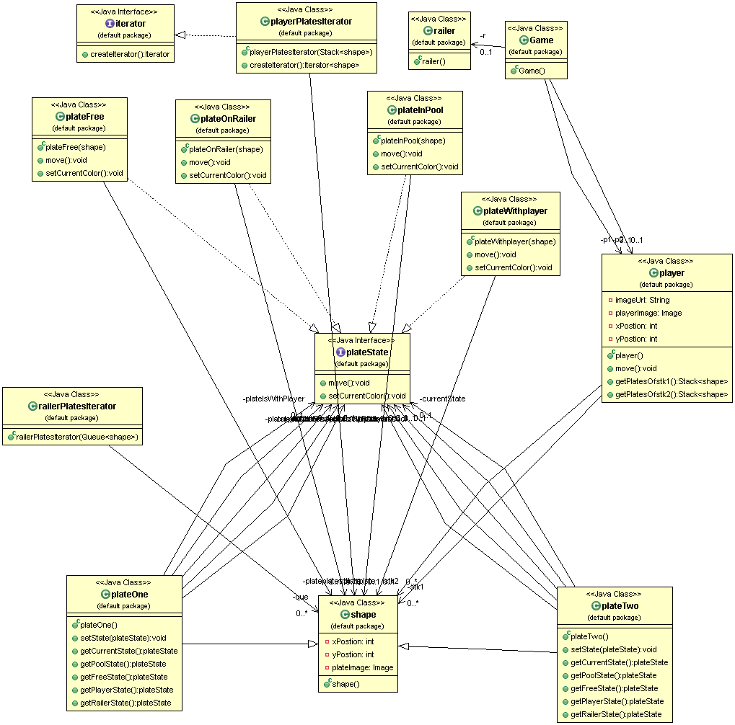

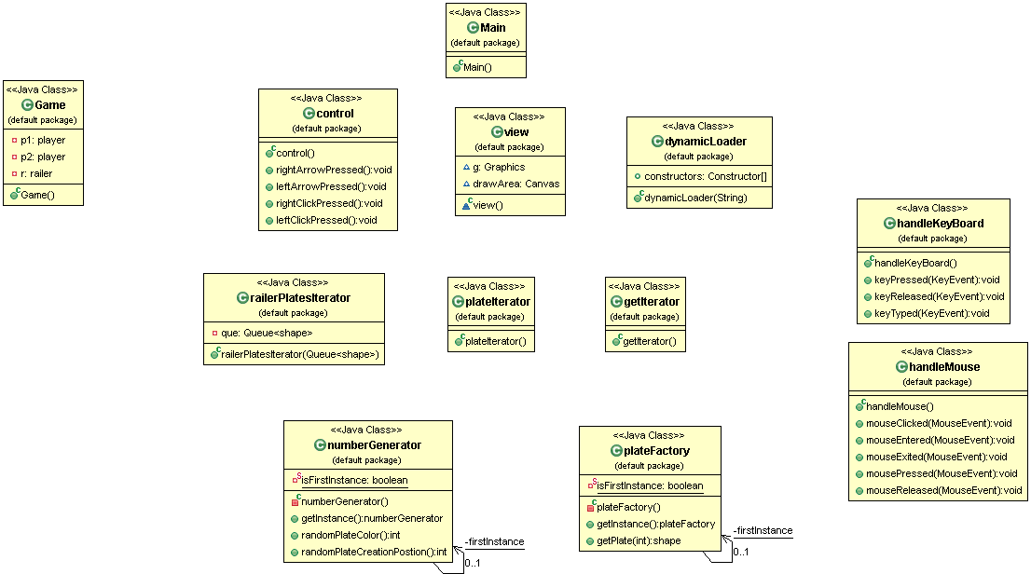

***User Guide***

1. First run the code from the Game Class.
2. Player one should use the arrows of the keyboard to move his/her Clown.
3. Player two should use the right and left mouse buttons to move his/her Clown.
4. A continues flow of plates will fall randomly in the game plane.
5. If a player is in suitable range from the plate when it lands then the plate will be held by the Clown in the appropriate hand.
6. If a player gathers Three consecutive Shapes of the same color (regardless of its type ) these three shapes will be popped and returned to the pool.
7. Press “S” on the keyboard to save and Press “L”on the keyboard.
8. The Game ends if any player reaches the limit of number of accumulative shapes with deletion
9. A player wins when the game ends and he/she has maximum score.

***Design Decisions***

* Run the application from class Game.
* Closing from the close window will cause an error.
* We load the classes PlateOne and PlateTwo once in the plate factory.
* We did not use a JFileChooser to make it game-like.

***Design Description***

* We put our model in Class Game
* Our View and Drawing occurs in class paint
* All the Control is in classes Control and PlateControl.
* We Dynamically load Classes Plate and Cup in the start of the game.
* The Model is accessed by the view and the Controllers
* The Controllers can access all classes
* The Model Only contacts the Controllers
* We Strongly designed the STATE DESIGN PATTERN , we analyzed all possible states in which the Shapes(Cups/Plates) could exist in and made transitions between them efficiently and Intelligently
* Class PlatePool makes LAZY INSTATNTIATION to the Shapes when needed
* Class ControlPlate Updates all transitions of all the Shapes and Observes the rest of the plates and the plates notifies the class with the updates…. In this class exists an array of shapes inService which contains all shapes in motion .
* Once Three shapes of the same color are put on one stack they disappear to the pool which reuses them again and generates them on the railler
* The NumberGenerator Class is the CONTROL CENTER OF RANDOMIZATION needed in any class in our humble project. It generates the endpoint trajectory of the shapes on leaving the railler and randomizes the types and colors of shapes and which railler the next shape out of the pool will move on.

